Logged on to Azure portal and created a Windows 11 VM
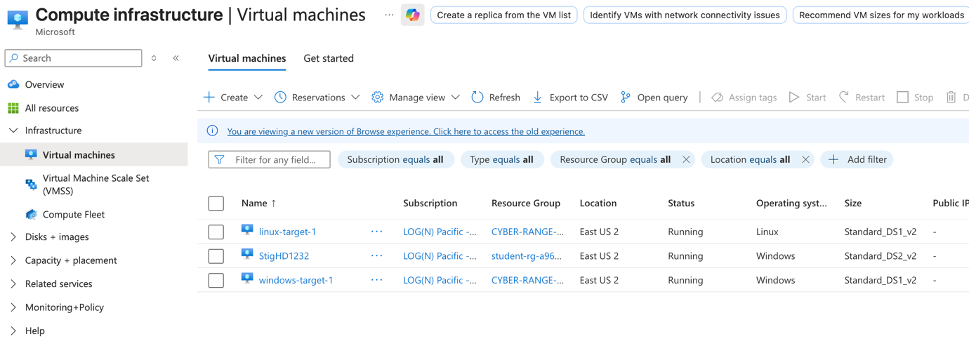

Allowed the VM to be scanned by the tenable app
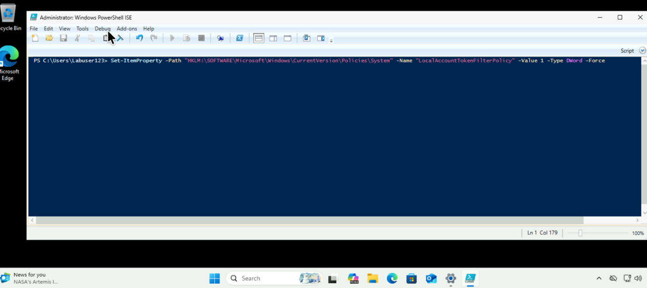

Logged into tenable.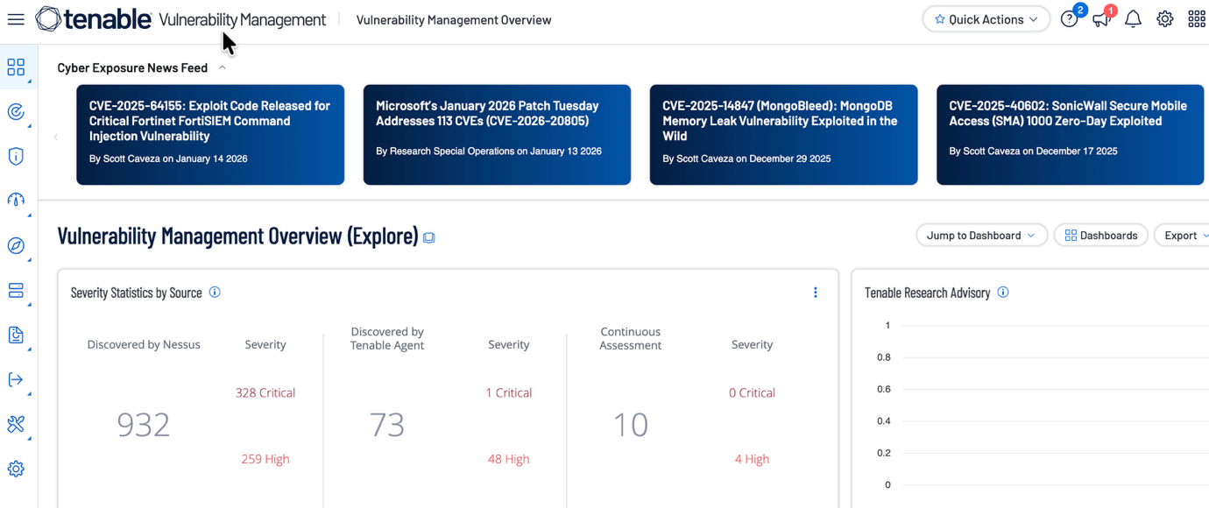

Created a Policy Compliance Auditing scan
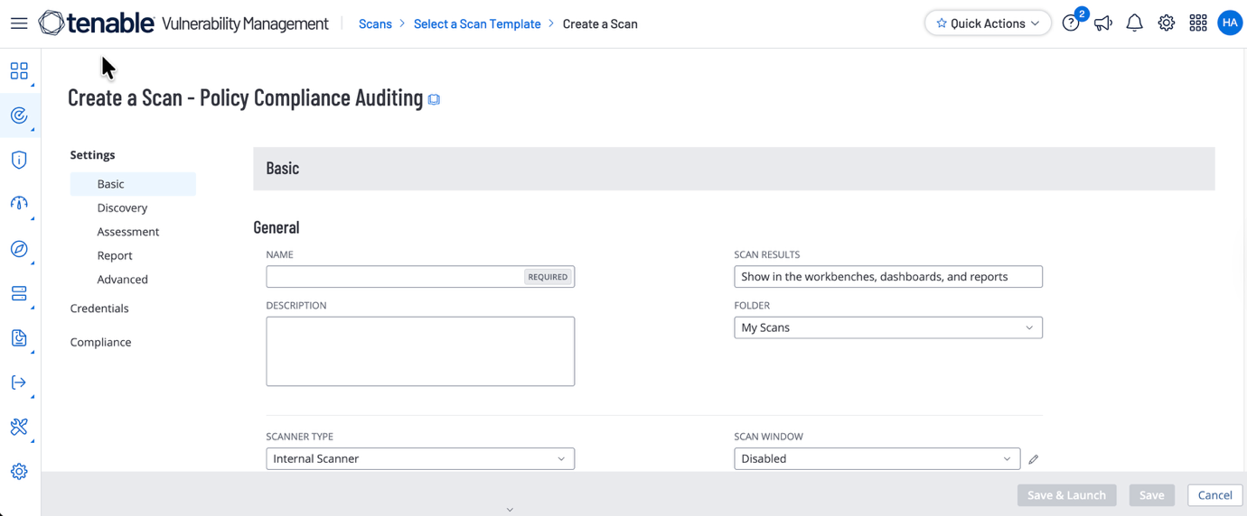

Entered the credentials of the VM
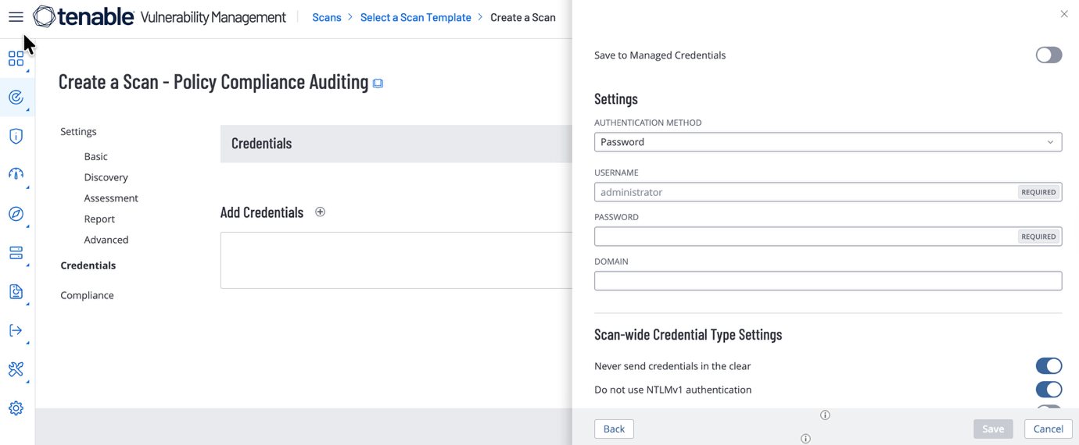

Choose DISA STIG compliance check

Disabled the Firewall for the scan to be able to do its job
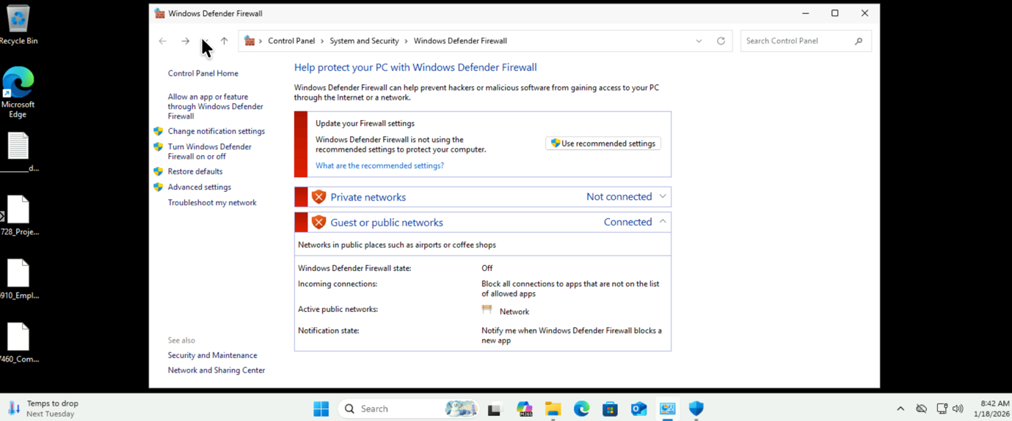

Analysed the results
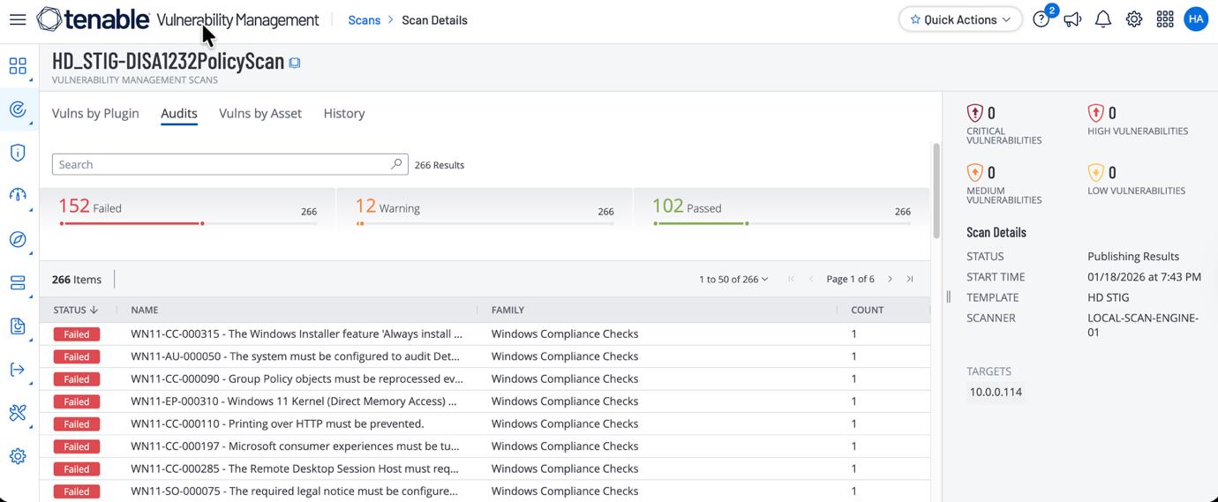
With powershell and Google Gemini as help started remediating the STIGs
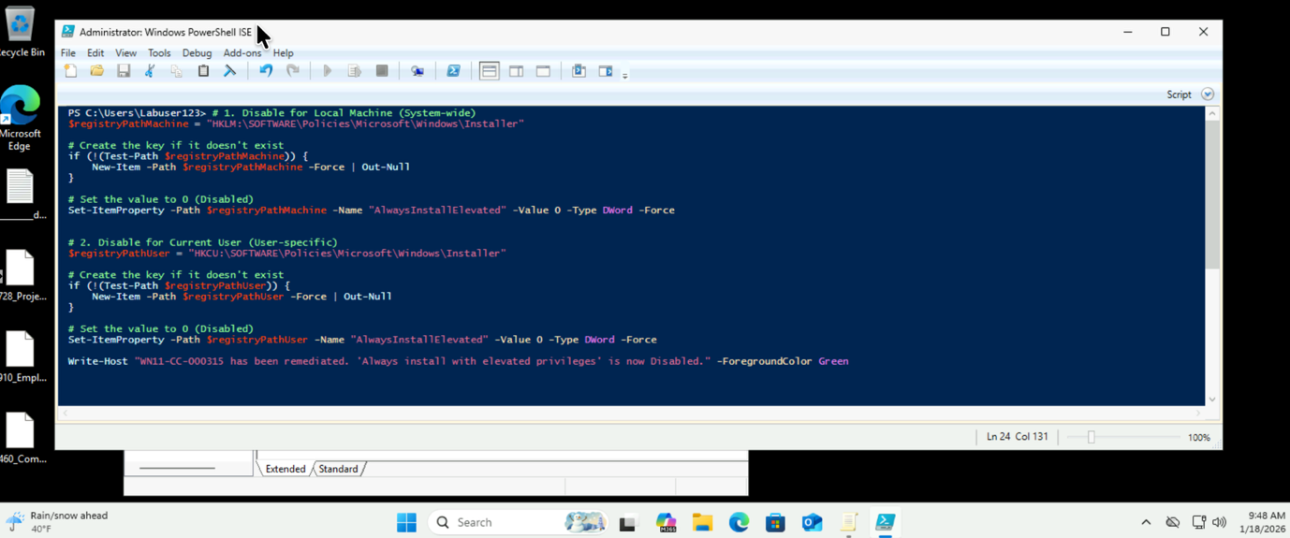

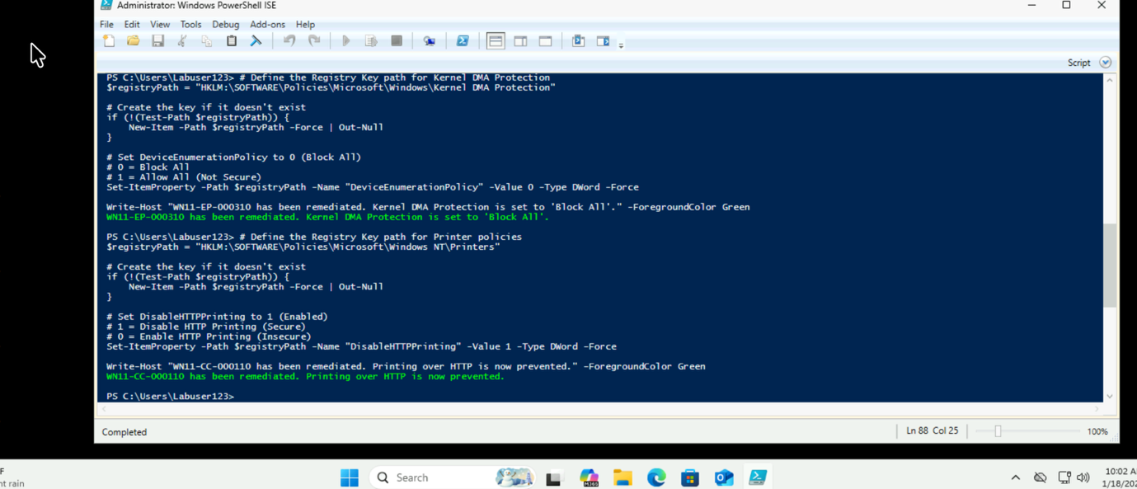

Also tried doing some manual STIG remediation
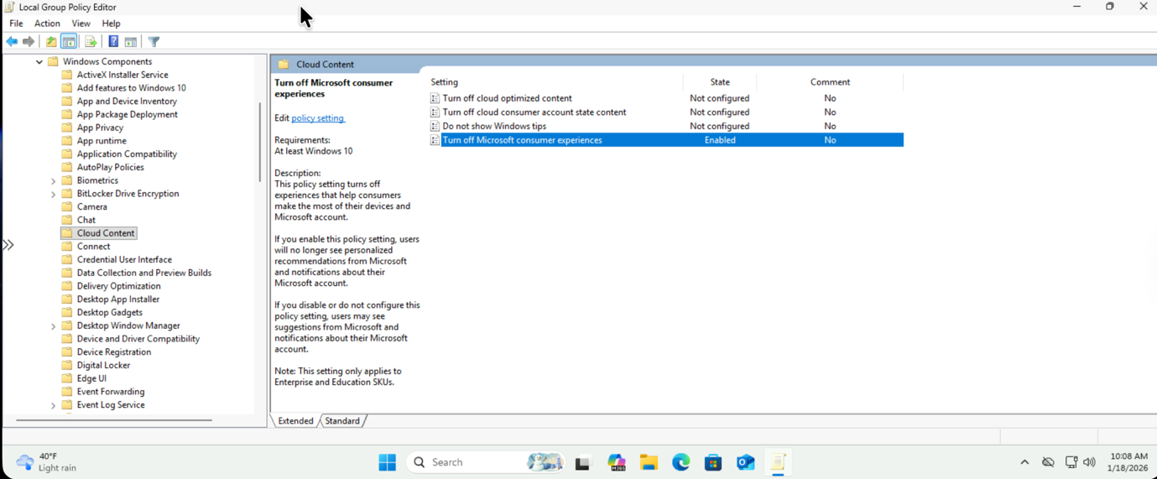
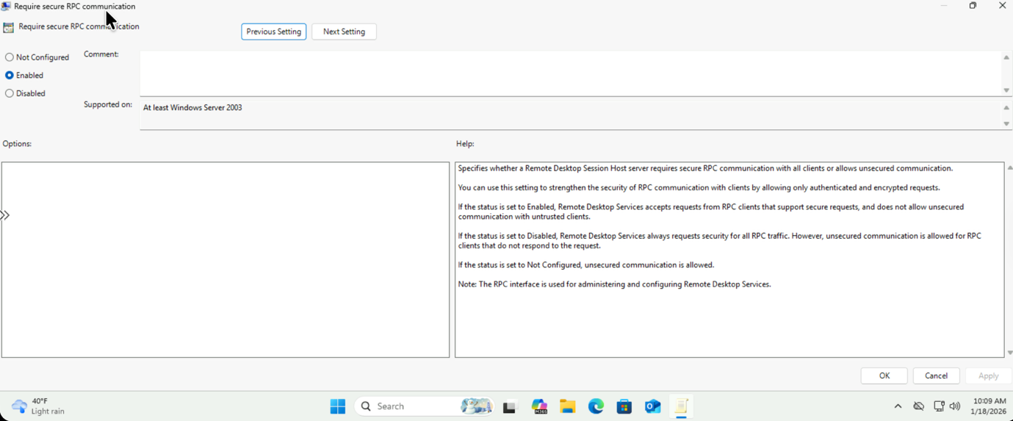
These are the STIGs that I remediated
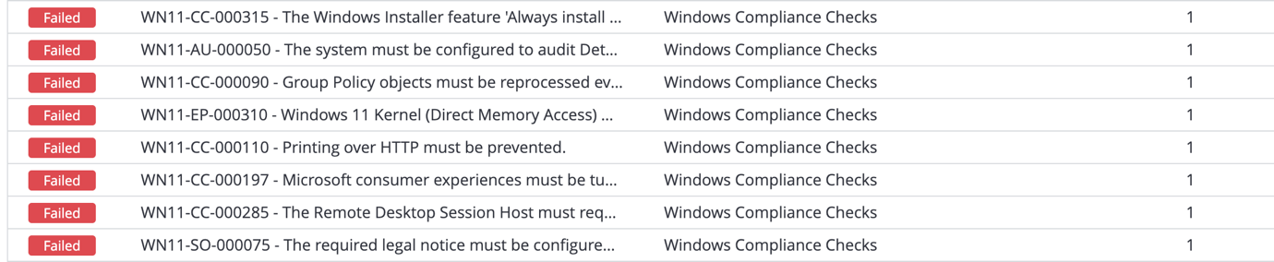

Rescanned the VM for STIGs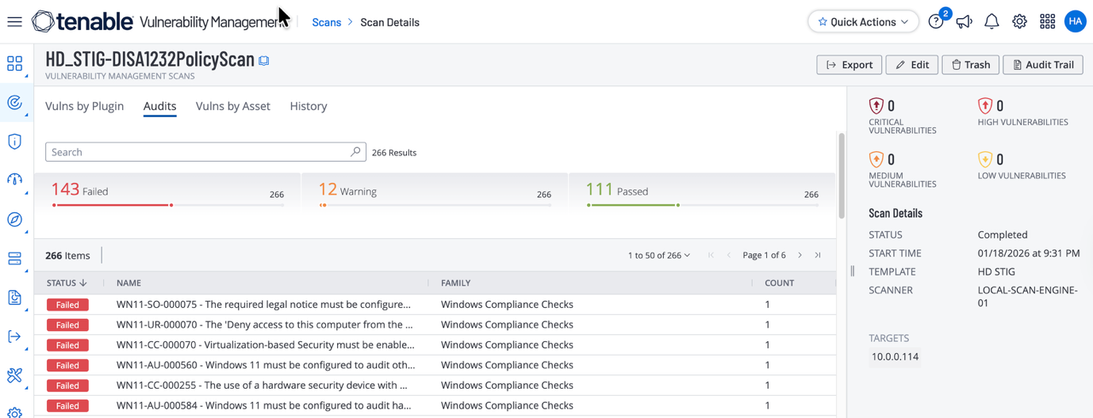

Checked the STIGs that got remediated.
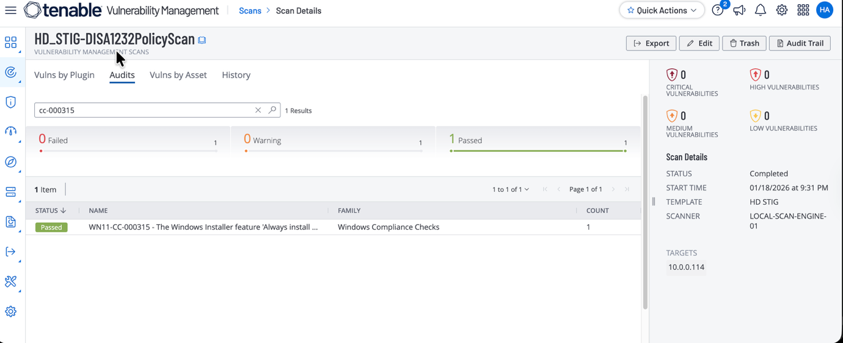

Here is the full list of Stigs that I was successful at remediating
STIG Application (STIG-ID: WN11-CC-000315)
STIG Application (STIG-ID: WN11-AU-000050)
STIG Application (STIG-ID: WN11-CC-000090)
STIG Application (STIG-ID: WN11-EP-000310)
STIG Application (STIG-ID: WN11-CC-000110)
STIG Application (STIG-ID: WN11-CC-000197)
STIG Application (STIG-ID: WN11-CC-000285)

